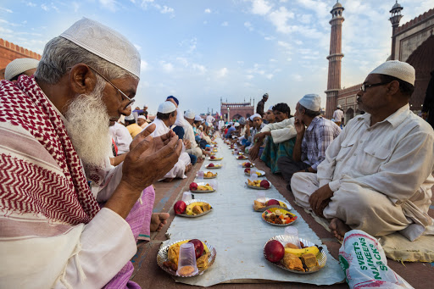



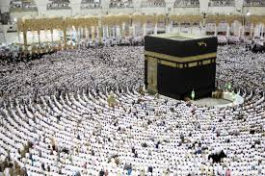

Ramadan Mubarak From JBS USA!
Safe Ramadan Practices During the Pandemic (COVID-19)
- To avoid crowded gathering associated with Iftar buffets (Breaking the fast), consider the physical distancing measures in place.
- During ablution before prayers:
- Use soap, water and hand sanitizers.
- Use disposable tissues and bins.
- Personal prayer rugs should always be placed over carpets and tiles.
- Always practice physical distancing.
- Use religious and cultural greeting that avoid physical contact. Please avoid hand shaking, hugging and touching while greeting each other.
- Stop crowded numbers of people gathering in places associated with Ramadan to practice the social distancing measures.
- Practice physical distancing by strictly maintaining a distance of at least 6 feet between people at all times.
- Always wear masks when coming to work and going home.

JBS Wishes A Happy, Healthy and Safe Ramadan For You and Your Families!

